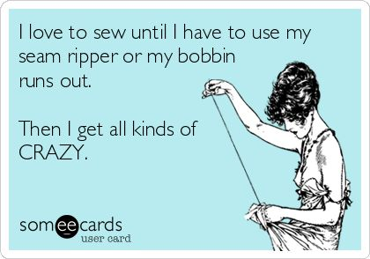Name_____________________________ period________

Home & Career Skills

Sewing Techniques

Directions: Use the word bank below to complete questions 1-10. Write the word to the left of each number. 5 pts. each with correct spelling. -1 for incorrect spelling.

Word bank: **counter, spool pin, bobbin, pins, lifter, flat, iron, down, back, towards**

________________1. Used to hold the spool of thread on top of the sewing machine.

________________2. A smaller “spool” of thread that is placed under the bobbin cover.

________________3. When sewing the presser foot should be in the ___ position.

________________4. The presser foot ____ raises and lowers the presser foot.

________________5. To “press” fabric means to _____.

________________6. When sewing both feet should be ____on the floor.

________________7. ____ are used to hold two pieces of fabric together.

________________8. When threading a sewing machine the bobbin should turn____

clockwise.

________________9. Always ____ stitch or reverse at the beginning and end of your sewing

lines.

_______________10. When turning the hand wheel, always turn it _____ your body.

Read each statement and **write the word TRUE or FALSE**. NO T’s or F’s. -1 pt. for each T or F

___________11. To see if the iron is hot you should touch the face of the iron with your hand.

___________12. When you turn the power on the sewing machine the light should turn on.

___________13. You should always test your threading on scrap fabric prior to sewing your

project.

___________14. When you are done using the iron, place the iron face down on the ironing

board.

___________15. Dress maker shears are used to cut fabric only, not paper.

___________16. The ***presser foot*** controls the speed of the sewing.

___________17. To ***reverse stitch*** you must push the button that looks like a U-turn.

___________18. If you make a sewing error and need to remove stitches the best tool to use is

a seam ripper.

___________19. A seam is where two pieces of fabric have been sewn together.

___________20. If you turn the sewing machine off and turn it back on the machine will

automatically return to its original settings.